**Lab 2: Signal generation and manipulation**

**THEORY:**

* Discrete time signal:
  + A discrete-time signal is a time series consisting of a sequence of quantities obtained by sampling continuous time signal.
* Continuous time signal:
  + A continuous-time (CT) signal is a function, s(t), that is defined for all time t contained in some interval on the real line.
* Square wave:
  + A square wave is a non-sinusoidal periodic waveform in which the amplitude alternates at a steady frequency between fixed minimum and maximum values, with the same duration at minimum and maximum.
* Sawtooth wave:
  + The sawtooth wave is a kind of non-sinusoidal waveform. It is so named based on its resemblance to the teeth of a plain-toothed saw with a zero rake angle.

1. Construct a Continuous and Discrete sine & cosine wave having amplitude=5 unit, frequ-ency.=3Hz then plot the signal all in single screen.

clc

close all

clear all

A=5;

f=3;

t=0:0.01:1;

x=A*sin(2*pi*f*t);

y=A*cos(2*pi*f*t);

subplot(221);

plot(t,x);

xlabel('time');

ylabel('amplitude');

legend('sinewave');

title('Continuous Sine/ Sameep Dhakal/563');

subplot(222)

plot(t,y);

xlabel('time');

ylabel('amplitude');

legend('coswave');

title('Continuous Cos/ Sameep Dhakal/563');

subplot(223)

stem(t,x);

xlabel('time');

ylabel('amplitude');

legend('sinewave');

title('Discrete sine/ Sameep Dhakal/563');

subplot(224)

stem(t,y);

xlabel('time');

ylabel('amplitude');

legend('sinewave');

title('Discrete cos/ Sameep Dhakal/563');

grid on;

OUTPUT:

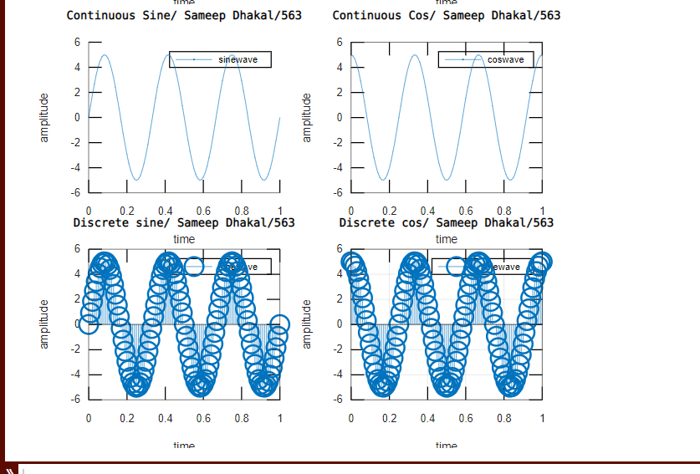

2. Construct a square wave having amplitude = 5unit, Frequency = 3Bz and duty cycle =1

clc

close all

clear all

A=5;

f=3;

t=0:0.0001:1;

x=A*square(2*pi*f*t*1);

plot(t,x);

axis([0 1 -5.5 5.5]);

xlabel('time') ;

ylabel('amplitude');

legend('SquareWave');

title('Square Wave/ Sameep Dhakal/563');

grid on;

OUTPUT:

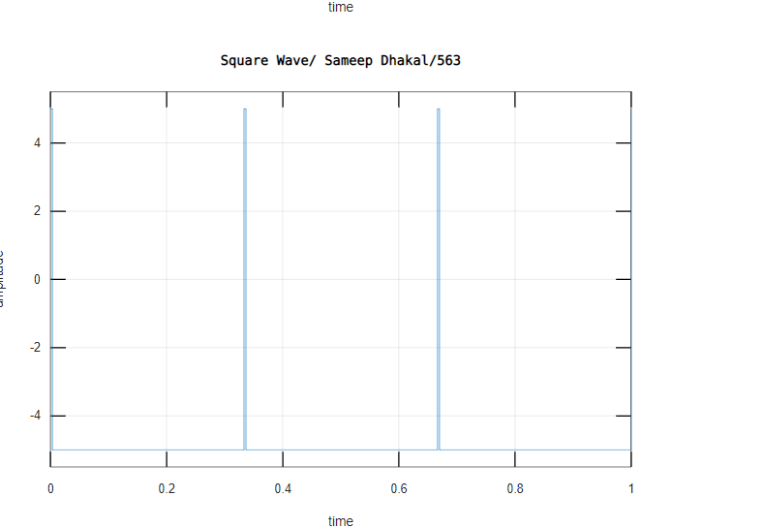

3. Construct a square wave having amplitude = 5unit, Frequency = 3Hz and duty cycle =20%, 50%, 90% all in one screen.

clc

close all

clear all

A=5;

f=3;

t=0:0.0001:1;

x=A*square(2*pi*f*t,20);

y=A*square(2*pi*f*t,50);

z=A*square(2*pi*f*t,90);

subplot(311);

plot(t,x);

axis([0 1 -5.5 5.5]);

xlabel('time') ;

ylabel('amplitude');

legend('SquareWave');

title('Square Wave(20)/ Sameep Dhakal/563');

subplot(312);

plot(t,y);

axis([0 1 -5.5 5.5]);

xlabel('time') ;

ylabel('amplitude');

legend('SquareWave');

title('Square Wave(40)/ Sameep Dhakal/563');

subplot(313);

plot(t,z);

axis([0 1 -5.5 5.5]);

xlabel('time') ;

ylabel('amplitude');

legend('SquareWave');

title('Square Wave(90)/ Sameep Dhakal/563');

grid on;

OUTPUT:

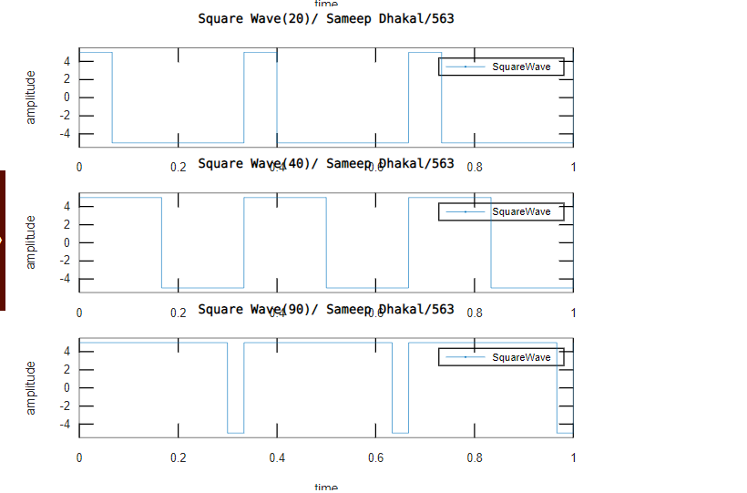

4. Construct a saw-tooth wave having amplitude = 5unit, Frequency = 3Hz and .width = 0.1

clc;

close all;

clear all; a=5;

f=3; t=0:0.0001:1;

x= a*sawtooth(2*pi*f*t,0.1);

plot(t,x);

xlabel('time');

ylabel('amplitude');

legend(‘Sawtooth’);

title('Sawtooth Wave/ Sameep Dhakal/563');

grid on;

OUTPUT:

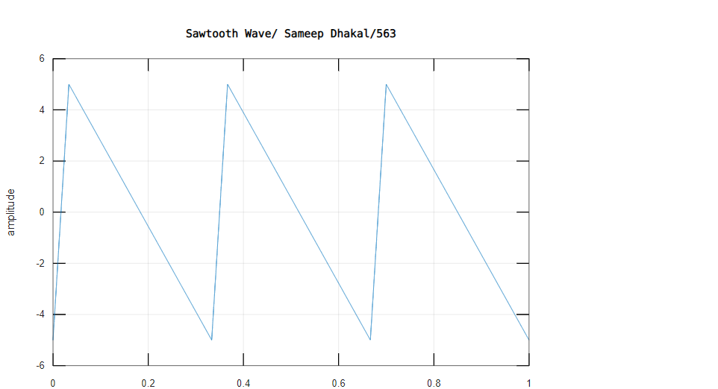

5. Construct a sawtooth wave having amplitude = 5unit, Frequency = 3Hz and duty width =0.2, 0.5, 0.7, 0.9 in one screen.

clc;

close all;

clear all;

a=5; f=3;

t=0:0.0001:1;

x= a*sawtooth(2*pi*f*t,0.2);

subplot(411);

plot(t,x);

xlabel('time');

ylabel('amplitude');

title('Sawtooth Wave/ Sameep Dhakal/563');

grid on;

y= a*sawtooth(2*pi*f*t,0.5);

subplot(412);

plot(t,y);

xlabel('time');

ylabel('amplitude');

title('Sawtooth Wave/ Sameep Dhakal/563');

grid on;

z= a*sawtooth(2*pi*f*t,0.7);

subplot(413);

plot(t,z);

xlabel('time');

ylabel('amplitude');

title('Sawtooth Wave/ Sameep Dhakal/563');

grid on;

r= a*sawtooth(2*pi*f*t,0.9);

subplot(414);

plot(t,x);

xlabel('time');

ylabel('amplitude');

title('Sawtooth Wave/ Sameep Dhakal/563');

grid on;

OUTPUT:

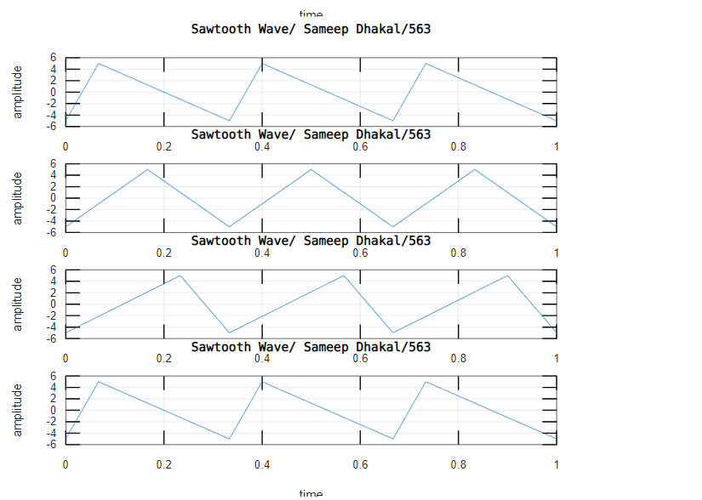

Discussion And Conclusion :

In this lab we plotted different types of waves and learn to use subplot in graph. We constructed waves with different duty cycles.